Umbilical Cord Prolapse

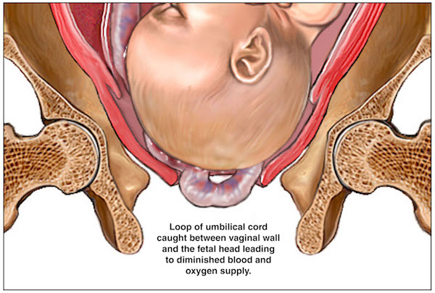

Cord prolapse occurs in 0.6% of deliveries. The risk is increased with fetal malpresentations, especially when the presenting part does not fill the lower uterine segment, as is the case with incomplete breech presentations (5-10%), premature infants, and multiparous women. ^{[69]}

Causes include abnormal presentation, a long umbilical cord, polyhydramnios, prematurity, and an unengaged presenting part.

History and Physical
- The occurrence of fetal bradycardia in the setting of ruptured membranes should prompt immediate evaluation for potential cord prolapse.
- There are two forms of umbilical cord prolapse.[1]
  - overt prolapse occurs when the cord exits the cervix before the fetal presenting part.
    - Dx: the cord is palpable as a pulsating structure in the vaginal vault or visibly protruding from the vaginal introitus;
    - Typically accompanied by fetal bradycardia or severe variable decelerations, in approximately two-thirds of cases
  - occult prolapse occurs when the cord exits the cervix with the fetal presenting part.
    - the cord is not visible or palpable ahead of the fetal presenting part. only fetal heart rate abnormalities may appear.
    - The diagnosis should be a consideration in cases of unexplained fetal heart rate changes in the setting of recent membrane rupture or other maneuvers that increase the risk of prolapse (for example, placement of a fetal scalp electrode).

Treatment / Management
The definitive management of umbilical cord prolapse is expedient delivery; this is usually by cesarean section. In rare cases, vaginal delivery or operative vaginal delivery may be faster and, thus, preferable, but this should only occur under the presence and guidance of an experienced obstetrician.
Until delivery is possible, the cornerstone of management of umbilical cord prolapse is funic decompression, relieving the pressure on the cord by elevation of the fetal presenting part. Studies suggest that the interval to funic decompression may be more important to outcomes than interval to delivery.
- Decompression should be done manually by the medical provider through the placement of their finger or hand in the vaginal vault and gentle elevation of the presenting part off the umbilical cord.
- The provider should be conscientious not to place any additional pressure on the cord, as this can cause vasospasm and worsen outcomes.[9]
- Placement of the mother in a steep Trendelenburg or knee-chest position can also aid in cord decompression.
- In cases of a potentially prolonged interval to delivery (i.e., the need for transfer to a hospital with obstetric capabilities), saline infusion into the bladder may aid in funic decompression and remove the need for continuous manual elevation by the provider.[10][11]
- If fetal decelerations persist and delivery is not imminent, the administration of a tocolytic can be attempted to relieve pressure on the umbilical vessels and to improve placental perfusion, thereby improving blood flow to the fetus.[12][13]
- Reduction of the cord into the os, which was common before the widespread availability of cesarean sections, has been associated with increased fetal mortality and is not routinely recommended except in cases of an expected long interval to delivery where other maneuvers have failed.[1]
If the cord is visibly protruding from the introitus, it should remain warm and moist because the ambient temperature is significantly colder than the temperature in the uterus and can result in vasospasm of the umbilical arteries, contributing to fetal hypoxia.[1] One method described as preventing this is the replacement of the cord into the vaginal vault followed by insertion of a moist tampon to keep it in place.[14]
In very rare cases of umbilical cord prolapse in peri-viable pregnancies, case studies demonstrate that conservative management may allow the continuation of the pregnancy until reaching a more desirable gestational age.[9][15] However, a frank discussion should take place with the patient regarding the experimental nature of this treatment and its potential risks.
Pre-viable gestational age, lethal fetal abnormalities, or fetal demise are not indications for expedient delivery, and instead, a dilation and evacuation or labor induction should be the therapeutic choice, dependent on gestational age or maternal preference.[5]
Prognosis
The rate of fetal mortality in umbilical cord prolapse is estimated to be less than 10%.[9][2][4] This reduction is a drastic decrease from earlier estimates of mortality, which ranged from 32 to 47%, which researchers hypothesize is due to the increased availability of cesarean sections and advances in neonatal resuscitation.

