Uterine Atony

Learning Objectives
By the end of this simulation, you will be able to:
- List the most common risk factors for postpartum hemorrhage
- Effectively communicate the critical tasks that should be performed when this complication occurs
- Explain correct medications and interventions that should be undertaken to control a postpartum hemorrhage
- Demonstrate how to effectively communicate during a delivery complicated by postpartum hemorrhage

1.0 Example Case Scenarios

CLINICAL SCENARIO #1

Mrs. Blynch is a 30y/o G3P3003 who just delivered a 4210 gram male infant by spontaneous vaginal delivery. The placenta delivered spontaneously but your nurse is concerned with the amount of bleeding she is seeing. The patient did not have an episiotomy and she does have an IV in place with oxytocin running at this time. The estimated blood loss at the time of delivery was 350cc.

CLINICAL SCENARIO #2

Mrs. Anna Tony is a 26y/o G1P1001 who was delivered by forceps approximately 1 hour ago for a non-reassuring FHRT. She was in labor for over 20 hours and pushed for an hour before having forceps placed. Her prenatal course was uncomplicated and has no significant medical history. After delivery, a second-degree laceration was repaired, and the placenta delivered spontaneously and appeared intact. Her estimated blood loss at the time of delivery was 450cc. Over the past 10 minutes, she has soaked an entire pad and she would like you to come and evaluate the patient.

2.0 Pre-Simulation Briefing/Orientation:

• Set the stage for the simulation by doing the following:
- Discuss what the learning objectives are for the day i.e. care of patients with obstetric emergencies, communication, and leadership in a crisis
- Review the Postpartum Hemorrhage Clinical Checklist

• Read these basic instructions to all participants:
- You will be briefed by the simulation staff and then come to the room when requested.
- You may ask questions if you have them, and please remember to:

1. Treat the scenario as real as possible
2. Use personal protection equipment (gloves, etc.) as needed
3. Request assistance if needed
4. Ask for medications if you feel that you need them
5. You may request to move the patient to the OR if you feel this is necessary

3.0 Simulation Setup

Simulators to be used:
- Model Med PPH simulator

5.0 Case Flow/Algorithm with branch point and completion criteria:
1) Setup the delivery simulator as described above
2) Brief the initial provider on the clinical scenario Simulation:
Postpartum Hemorrhage (Uterine Atony)
Provider enters room.
The assistant playing the role of the spouse/family informs the provider that the patient is feeling dizzy and/or lightheaded (Initial vital signs: HR = 110 bpm, BP = 100/70)

Provider should recognize the situation as a postpartum hemorrhage and begin treatment

60 seconds after the initial vital signs are given, the maternal vital signs should change to the following: HR = 120 bpm, BP = 80/50)

120 seconds after the initial vital signs (total of 2 minutes into the simulation), the maternal vital signs should change to the following: (HR = 140 bpm, BP = 60/30)

The simulation ends when either of the following occurs:
1) The provider(s) have done all of the following
- Performs fundal massage
- Inspects the cervix/vagina for lacerations
- Administers two medications correctly (dose and route)*
(*If the medications are given incorrectly, either dose or route, then the uterus does not become firm and the bleeding continues)

2) A total of 5-7 minutes has elapsed
At either of the endpoints above, clearly state that the uterine tone and maternal vital signs have improved, the bleeding has decreased and the simulation is over

6.0 Post-Simulation:
- Gather the provider and/or team together to debrief and review performance
- Use the Postpartum Hemorrhage Evaluation Form

7.0 Postpartum Hemorrhage (Uterine Atony) Evaluation Form
https://www.acog.org/clinical/clinical-guidance/practice-bulletin/articles/2017/10/postpartum-hemorrhage

https://www.scdhhs.gov/sites/default/files/ACOGHEMChecklistStage1Stage4.pdf

Initial Actions

Stage 1 PPH:

- Record VS/O2 saturation every 5 minutes
- Monitor cumulative blood loss
- Insert foley catheter
- Ensure IV access: 16 gauge if possible
- Increase IV fluid (crystalloid: estimated blood loss in 2:1 ratio without oxytocin)
- Fundal massage
- Determine and treat etiology (4Ts – Tone, Trauma, Tissue, Thrombin)
- Contact Blood Bank: Type and Crossmatch 2 units PRBCs
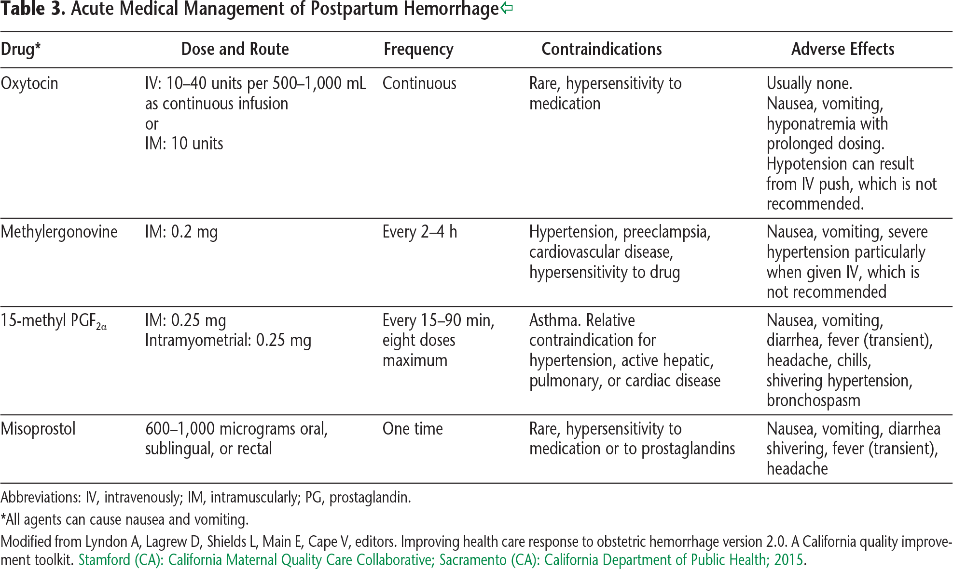

Tranexamic acid is an antifibrinolytic agent given intravenously or orally 1g.

Stage 2 PPH:

Normal vital signs and lab values:
Continued bleeding EBL up to 1500mL OR any patient requiring more than 2 uterotonics

- Obtain 2nd IV access
- STAT labs with coags/fibrinogen
- Medications
- Transfuse per clinical signs and symptoms
  - Notify blood bank of OB hemorrhage, bring 2 units PRBCs to beside, thaw 2 units FFP (DO NOT wait for labs)
- For uterine atony, consider uterine balloon or packing, possible surgical intervention
- Consider moving to OR
- Mobilize additional team members as necessary
- Warming blanket

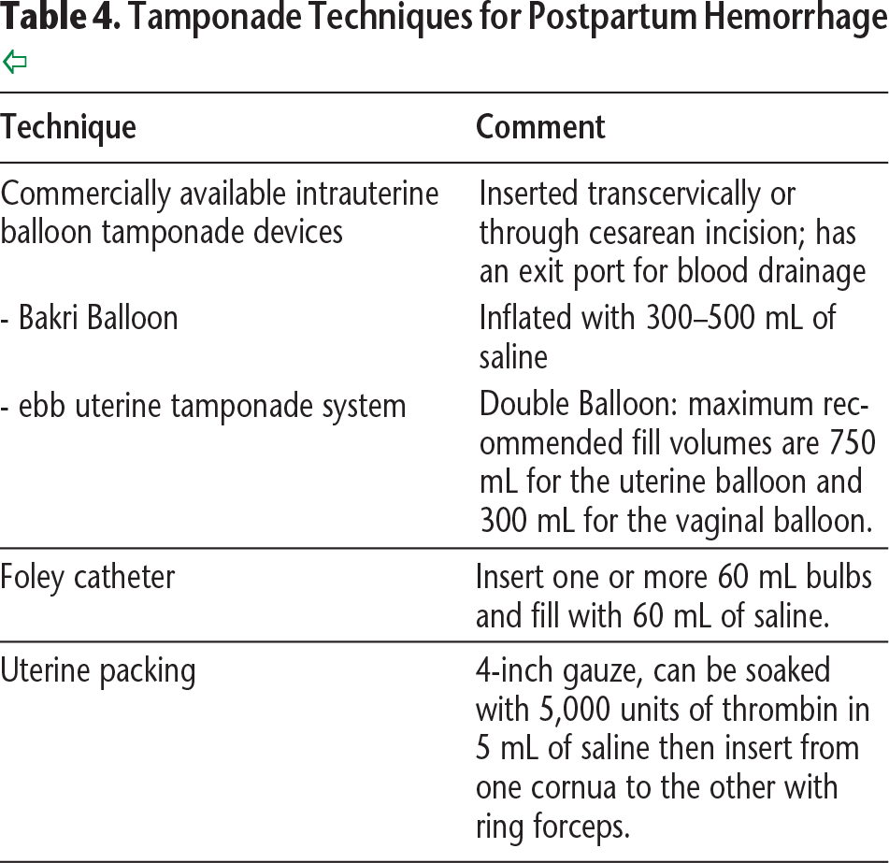

Stage 3 PPH
Abnormal vital signs/labs/oligouria:
Continue bleeding with EBL >1500mL OR >2 units PRBCs given OR patient at risk for occult bleeding (post-cesarean) & DIC

- Outline management plan, serial evaluation, communication plans with team
- Transfusion, RBC-FFP-Platelets in a 6:4:1 ratio (activate massive transfusion protocol MTP), if coagulopathic, add cryoprecipitate. Consider consultation for alternate agents
- Identify etiology for bleeding
- Rule out lacerations, coagulopathy, occult bleeding
- Achieve hemostasis immediately
- Adopt additional measures if poor response

Stage 4 PPH
Cardiovascular collapse
For patients with cardiovascular collapse in the setting of massive PPH consider the following:
- Profound hypovolemic shock
- AFE (sudden CV collapse followed by heavy uterine bleeding from uterine relaxation and associated coagulopathy)
- Immediate surgical intervention may be necessary
- Simultaneous aggressive blood and factor replacement and medical interventions initiated regardless of the patients coagulation status
- Expeditious hemostasis needed to maximize survival

Post-Hemorrhage: Debrief

